**The Book of the Dead**

Foy Scalf

Sept-Nov 2021

*9/12*

Papyrus of Ani, *Brit. Mus. 10470 sheets 5-6*

ha.t-a m r.w nw pri.t m hrw s[?]Tsi

s-Ax.w=i pri.t hAi.t[?] m Xr.t-nTr Ax.t m[?]

imnt.t nfr.t Dd.t hrw n qrs Aq m

xti pri.t Dt in m Any Asir sS Any inD[?] Hr=k kA imn.ti [n]

nsw.t nHH im=i ink nTr aA n gs-dp.t aHA.y rdi.n=i Hr=k ink wa m n

*9/13*

*What is the Book of the Dead?*

*“Flinders Petrie,” said Dr. Cairn, “mentions The Book of Thoth as another magical work conferring similar powers.”*

*“But surely, sir—after all, it’s the twentieth century—this is mere superstition!”*

*“I thought so—once!" replied Dr. Cairn. "But I have lived to know that Egyptian magic was a real and a potent force. A great part of it was no more than a kind of hypnotism, but there were other branches. Our most learned modern works are as children’s nursery rhymes beside such a writing as the Egyptian Ritual of the Dead!”*

*— Sax Rohmer, “Brood of the Witch Queen”*

Pyramid Texts, Coffin Texts, Books of Breathing, etc. overlap with the BD spells. In fact the oldest instance of a BD spell was found on a coffin. However, there are specific orderings of BD spells that we don’t find in, say, the Coffin Texts.

We have found NO papyrus versions of the BD in the tombs of pharaohs. It seems that papyrus was considered too cheap and/or perishable. Tutankhamun’s Spell 151(?) was written on the inside of his mask and on his magical bricks.

The title “Book of the Dead” originates with Lepsius’s publication *Der Todtenbuch des Aegypten* (1842). That was a study of the papyrus of Iufankh. The English title is a later translation by Birch.

Lepsius used Iufankh for the initial numbering of the spells.

Papyrus of Ani:

- Retrograde hieroglyphs (columns left to right, hence unrolled “in reverse”)

- Starts with a hymn to the sun (BD 16), not with BD 1!

- Note how BD 2 also uses the phrase “spell for going out by day” (“…and for living after dying”)

“For the Egyptians, the BD is oral. It’s more about spells being read aloud, than being written down.”

“The BD is not about death. It is about ‘living again’, or wHm anx: the solar-Osirian cycle.”

*9/19*

P. Berlin 3031

tA is.t[??] i gm m [?] r xx.wt n nsw.t Usr-MAat-Ra anx[.w]-Dd[.w]-s[nb.w] m Xr.t-nTr

P. Leyde T25

P. Leyde T37

P. Leyde T31A

P. Leyde T31B

P. Berlin 3031

That book: O [you], [it] was found at the neck [Faulkner 197] of the King Usermaatre [Rameses], l.p.h., in[?] the necropolis [Faulkner 204].

*9/20*

*How to Work with the Book of the Dead*

*“Now, the famous ‘Grammaire’ proves that Champollion had examined every part of the work which he called a ‘Rituel,’ and the many short passages which he translated show that he recognized the nature of its contents and rightly appreciated its great value from a religious point of view. But he analyzed no complete Chapter of it, and he translated no paragraph of any length, and the assertions that have been made to the effect that he was the first translator of the Book of the Dead are incorrect statements based upon insufficient information on the subject.”*

*— E. A. Wallis Budge,* The Mummy

Funerary literature is attested from 2350 BC through 200 AD. The “Book of the Dead” corresponds roughly to compositions attested in the period 1750 BC through 150 AD.

Long believed that the so-called “Saite Recension” (a specific, standardized selection and ordering) was introduced in the 26th (i.e., Saite) Dynasty. But now we believe it already appeared in the 25th (Nubian) Dynasty.

“They NEVER thought the mummy was going to break out of the coffin and walk around, like they do in *The Mummy* movies.”

1 Historiography of BD studies

2 English translations

3 Other publications

4 Databases

Ancient Egyptian historiography of ancient Egypt: The trope of spell texts being “found” texts, e.g.,

- Attribution of Spell 64 to Hordedef

- Attribution of Spell 166 to Rameses II

Athanasius Kircher (1602-1680): German Jesuit founder of Coptic studies and one of the earliest major claims to “deciphering” Egyptian hieroglyphs. Amassed Egyptian antiquities in his Musaeum Kircherianum.

Bernard de Montfaucon (1655-1741): French Benedictine paleographer, who wrote *Antiquity Explained and Represented in Diagrams*. Volume 2 is filled with images of Egyptian artifacts (including the Anubis archer in Foy’s article with Robert Ritner).

By the end of the 18th century: Masses of detailed but disorganized collections, unreadable transcriptions of hieratic (“looks like gibberish”), everything filtered through a classical (Greco-Roman) lens

Then THE FRENCH INVASION

Jean-Marcel Cadet (1751-1835): “Savant” who made fantastically accurate facsimilies, as early as 1805

Landmark book: *Description de l’Egypte*. Original copies burned during the Arab Spring in Egypt

Jean-François Champollion (1790-1832): DECIPHERMENT

Karl Richard Lepsius (1810-1884): Discovered the biliteral and triliteral signs; coined the term *Todtenbuch*, as mentioned

Lepsius’s facsimile caught on more than Cadet’s, mainly as a result of being post-decipherment.

Lepsius student Edouard Naville (1844-1926): Introduced “pantograph” to make scale drawings; introduced the parallel-column layout for comparing versions of the same spell from different sources

“Samuel Birch HATED E. A. Budge. Hated his guts… Budge’s translation of the BD is based on largely on Birch’s work, which was based on the work of Lepsius and Naville. And then, in 1898, after stealing the Papyrus of Ani from Egypt –

“I think this is one reason the British Museum liked him; Budge had no morals or scruples – the Egyptian authories put Budge under house arrest, so Budge threw a rooftop party, very sumptuous, and while the guards were there, he essentially cut up and stole the Papyrus of Ani – anyway, …”

Thomas George Allen (1885-1969): Part of Breasted’s “brain trust”; worked on the “Coffin Texts Project”

We will rely most on Quirke’s book. But it really looks like a compilation of notes going back to Quirke’s student days. Some of the translations seem really weird.

The canonical (up-to-date) reference for hieroglyphic transcriptions of each spell, in Naville’s format: *Totenbuchtexte*, ed. by Lapp and Lüscher

Databases:

- Totenbuch Project: <http://totenbuch.awk.nrw.de/>

- Thesaurus Linguae Aegyptiae

*9/26*

Papyrus of Ani, BD 72

*Transliteration*

1 ir

2 rx md.t tp-tA m sS.w Hr qrs r[?]-pw iw=f pri=f m

3 hrw m xpr.w nb mri=f [N36] n [?] di aq [G35] r s.t [?] n Sna.tw=f [V7]

4 iw di.tw n=f t Hnq.wt [?] wr n iwf Hr xA.t Wsir iw=f aq=f

5 m Htp r %x.ti IAr.w [?] r rx wD pn n imi.t Dd

6 [?] iw di.tw n=f i.t bty im=s wnn xr=f wAD mi wn.n=f

7 tp-tA iw=f ir=f mri=f n mi [?].n n psD.t nty m-dw

8 -A.t m [?] mAa.[t] Hh [1000000] n sp iw Wsir sS An.y ii[?]

*Translation*

1 As for

2 the one who knows the words, [which are] upon the earth in writing[s] on [his] tomb: [As for] him, he goes out in

3 the day in any [of] the forms he desires, in order[?] that he enters into the place where he is [“of his being”] repelled [Gardiner 522].

4 Bread and beer, and a great [quantity of] meat [Faulkner 13], are given to him upon the altar of Osiris. [As for] him, he enters

5 in peace into the Field of Reeds [Faulkner 9]. As for knowing this command of the one who is upon [?],

6 […] barley and emmer [Hoch 255] are given to him therein [“it”], by[? Faulkner 195] him, flourishing[? Faulkner 55] like he was

7 on earth. [As for] him, he does what he likes, [“of”?] like [that done by] the Nine of the Im-Du-

8 -at, [?] in truth, a million times. The Osiris, scribe Any, [?]

*9/27*

*Reading and Writing the Book of the Dead*

*“‘Possible, but not probable, in view of what the papyrus says,’ Dr. Taylor cut in. ‘I found the sheet of writing tucked between two layers of bandages—surreptitiously, I’d say—just after I’d completed my fluoroscopic inspection.’*

*De Grandin tweaked the needle-points of his small wheat-blond mustache. ‘Tiens, Monsieur, why do you torment us thus, making a long story still longer? What did it say, this twenty-times-accursed papyrus of yours?’*

*‘Plenty,’ Dr. Taylor answered. ‘I haven't finished translating it, but even its beginning has an air of eerie mystery. She describes herself as Nefra-Kemmah, servant of the Most High Mother, the Horned One, the Lady of the Moon—in fine, a priestess of the goddess Isis.’”*

*— Seabury Quinn, “Lords of the Ghostlands”*

Foy showed a vignette of the Judgment Scene and asked (as a trick question) which spell it was for. It turns out that the Judgment Scene can be paired with BD 30b, not just BD 125.

We believe the language in the BD is the Middle Egyptian spoken in 2100 BC. And Foy personally thinks that scribes kept studying this (ancient) language up through 150 AD, in order to keep producing religious texts like the BD.

The Pyramid Texts do not show any human figures, only human body parts at best. They are written in the third person. The signs are mainly carved hieroglyphs in the monumental style, hence very elaborate, but there are some examples in cursive.

The Coffin Texts use a mixture of first and second person. Majority written in cursive.

Dawn: Are [carved] hieroglyphs the “high” art form? Foy: It’s more that they were the most formal register. Carved vs. cursive is analogous to word processor vs. handwritten.

The BD is mostly in first person, and reaches its heyday in the New Kingdom. BD texts have extensive use of titles and rubrics. Pharaohs do not put BD papyri in their tombs, as a rule (with three exceptions) – they instead write the spells onto mummy adornments, magical bricks, etc. The majority are written in cursive hieroglyphs or hieratic, except that captions and additions are in hieroglyphs. Also, cursive hieroglyphs start to appear in retrograde by the New Kingdom. In the Late Period, spells start being written in demotic translations.

The first BD papyri appear in the 17th Dynasty.

First attestation of a BD spell was on the now-lost coffin of Queen Mentuhotep, of the 13th Dynasty, ca. 1650 BC. Found at Dra Abu el Naga, near Thebes.

Another early attestation: Cursive on a scarab of Sobekemsaf II, of the 17th Dynasty, ca. 1570 BC. Found at Qurna, again Thebes.

By the early New Kingdom, the preferred medium for transmitting the BD was linen shrouds, which helped lead to the column-writing format. Examples in the 18th Dynasty include the shroud of Thutmose III.

The Papyrus of Nu is from the 18th Dynasty, ca. 1450 BC. Found in Thebes.

Why retrograde??? One line of speculation is “for religious reasons”. Simpson’s article proposes, more mundanely, that they just wanted the text to follow along with the left-to-right orientation of the vignettes. Starts to look convincing once you look at enough large-scale vignettes, esp. ones with figures facing in both directions. But there are counterexamples to this hypothesis too! E.g., Papyrus of Any.

Monica Brown: If even the scribes often didn’t understand their texts, do we know if there was any anxiety about owners not being able to read/understand their copies and not being able to use them? Foy: This is one of the questions we know the least about! There are enough examples of severely-garbled papyri that garbling must have been very common overall…

Dick: Wasn’t there a case where a non-BD text was buried with the owner who thought he purchased a BD? Foy: I mean, you could even buy “models” of BD’s. A real BD cost six months’ wages of a “decently-paid” worker’s salary. “I like to compare it to buying a sports car.”

Many BD papyrus owners had two papyri: the usual BD papyprus, and also an “Amduat” version with many illustrations and little text.

“Saite” Recension: Lots of formats for interspersing the illustrations, e.g., along the top, stacked, etc. From 750 to 30[?] BC, most common format was blocks of hieratic below the illustration, *not* in columns.

In the late Ptolemaic to early Roman period, you see the scribes trying to transliterate(!) the Middle Egyptian language into Demotic script, with some Late Egyptian-isms creeping in. Have an example from Akhmim (pBerlin 10477) where a scribe misinterpreted a t (for “bread”) as a Late Egyptian definite article.

There are also examples (p. Bibliothèque Nationale149, pLeiden T32) where the scribes *translated* Middle Egyptian grammar into Late Egyptian grammar. [nA] sX.w n nA pyr.w … as a Late Egyptian version of the usual title.

These late examples don’t have images! Instead, the scribes will often include text summaries of the images that would have appeared in older manuscripts (in particular, of the Judgment Scene).

In the pBN 149 version of the Negative Confessions, it seems that the scribe translated all of the invocations as a single chunk, then realized they should have been *paired up* with corresponding negative confessions, then went back and started translating all of the negative confessions.

There are late spells (e.g., BD 164) that use Nubian! “Herepepegekeshereb … is your name in the Nubian language…”

*10/4*

*Making the Book of the Dead*

*“‘There is one ingredient which you can never get. Save that which is in the ring of Thoth, none will ever more be made.’ ‘In the ring of Thoth!’ I repeated; ‘where then is the ring of Thoth?’ … ‘My days after that were spent in study. I must find this subtle poison which was strong enough to undo the elixir. From early dawn to midnight I bent over the test-tube and the furnace. Above all, I collected the papyri and chemical flasks of the Priest of Thoth.’”*

*— Arthur Conan Doyle, “The Ring of Thoth”*

Distinction between academic setting of scribes who compiled the BD texts, versus workshop setting of craftsmen who copied out the paypri or wrote the texts onto amulets, bricks, etc. This can explain why, for instance, we find magical bricks that aren’t placed according to the instructions in the BD spells designed for them!

Spell 100:

- “Recitation over a blank papyrus sheet, upon which this spell is written together with this image which is on it in writing [made] from crushed green minerals mixed with myrrh water.”

- “Recitation over this text, written on a clean blank roll with power of green glaze mixed with water of myrrh, and given to the blessed spirit…”

Spell 30 rubric: “Recitation over a scarab of green stone, gilded with fine gold, its ring [made] from silver, and placed for the akh-spirit at its throat.”

Magical power of hieroglyphs:

- Written texts ground into potions, e.g., as in a tale of Setne Khaemwise

- Devotional touching of statues

- Apotropaic writing: Hieroglyphs of serpents, etc. were sometimes cut up to prevent them causing harm

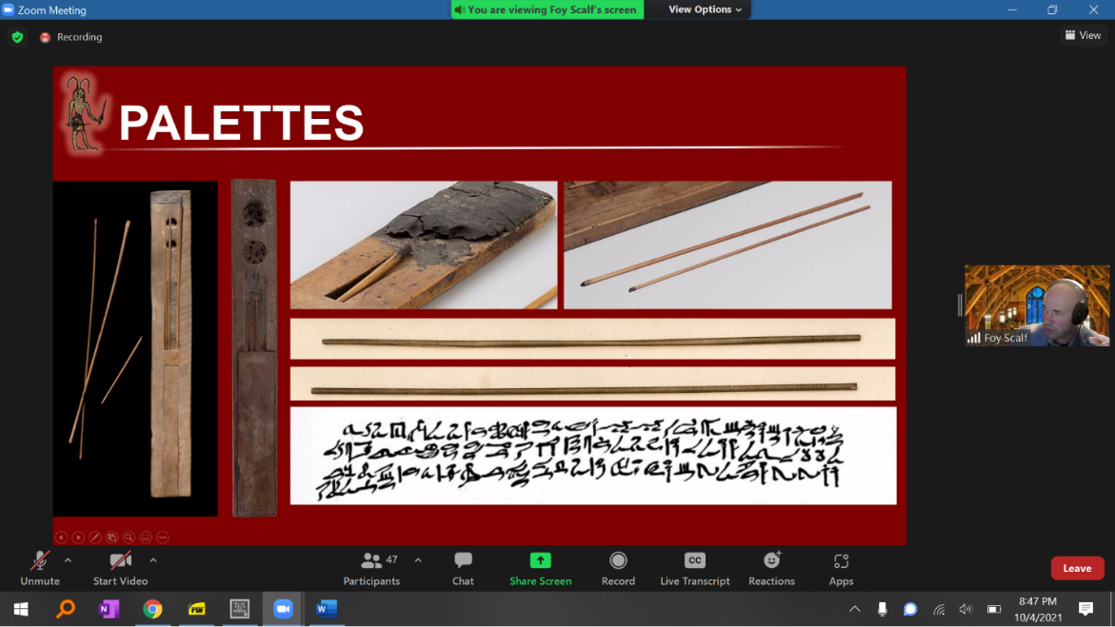

Starting in the Ptolemaic period, hollow reed pens begin to become popular. Function very much like modern fountain pens. Produces a line that is much more thin and consistent than that of the earlier brushes.

An example of reed-pen writing: The papyrus of Irtyuru. The lines are generally thinner than 1 mm! You can see why James Henry Breasted was so impressed by this papyrus.

Foy, answering Hongqi: From the *very beginning* of Egyptian writing, ca. 3250 BC, there was always a cursive style. So in some form, hieratic script was always present.

We see “extra space” in Irtyuru’s papyrus, where his name didn’t fill up the blank spaces in the papyrus he bought.

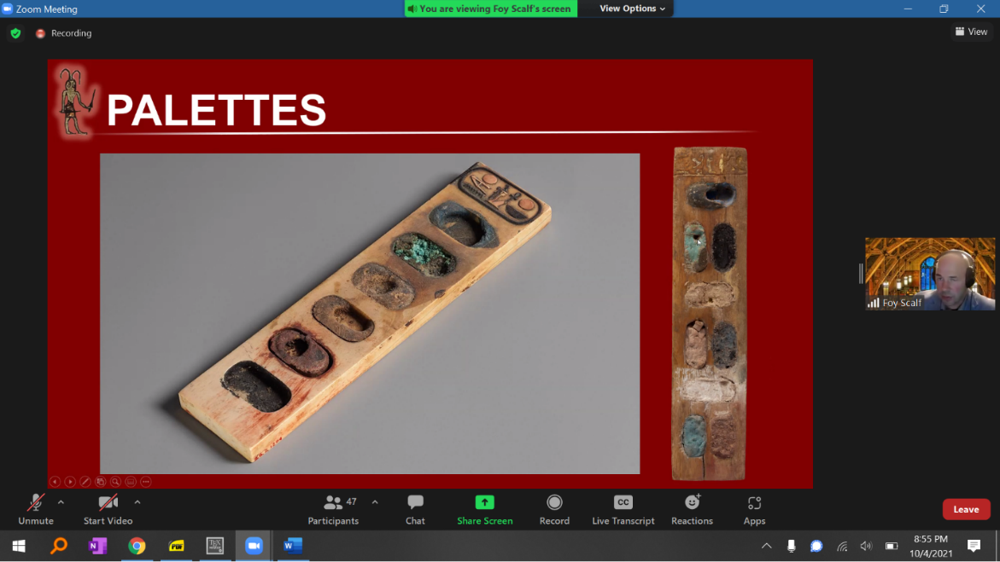

We have some very well-made BD papyri that belonged to owners who were scribes themselves. We wonder: Did the owners write their own BD papyri?

Foy: “I have a papyrus plant in my backyard. I’m trying to figure out how to keep it alive over the winter. It’s getting pretty big, looks pretty cool…”

Papyrus strips were glued down left to right, so that the overlaps would slope downwards from the perspective of (right-to-left) writing. Then the assemblage was usually smoothed out, e.g., with a pumice stone.

Steps to copying out a (standard) text onto papyrus:

(1) Draw a grid of columns, along with the lines to mark off the header illustrations. We have examples that show small tick marks every 10 columns, i.e., the scribe was keeping track of many columns had been drawn.

(2) Fill in the text, except possibly leaving spaces for the future owner’s name. (Sometimes everything was written in one go, e.g., the papyrus of Nesshutefnut.)

(3) Illustrations were the last step. We know this because we have examples of drafts where everything was done except the illustrations.

In the blank space for an illustration, we find the instruction iri mi sSm pn nty m sS.w, meaning, “Make according to this plan which is writing.”

Barbara: How is it determined which spells will be used[,] and in which order? Foy: Short answer is: We don’t know for sure.

Foy: What does this [bungled illustration job in Papyrus Ryerson] tell you about the illustrator? Everyone: He couldn’t read the text.

“The scribe noticed, ‘Oh, our illustrator’s not really up to snuff on this one…’ and put in a note *in Demotic*.”

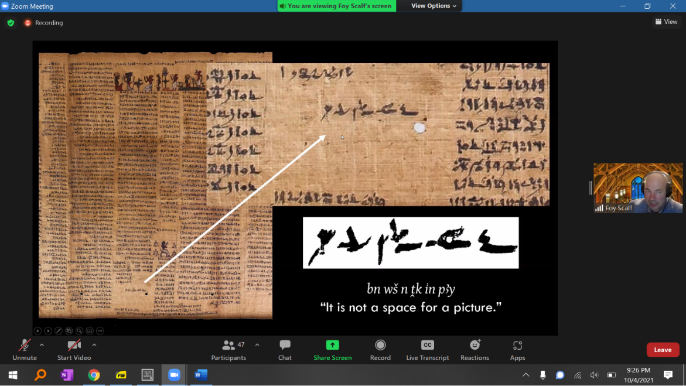

And in a copy of Spell 140 [the same spell?] in the Louvre: The exact same text:

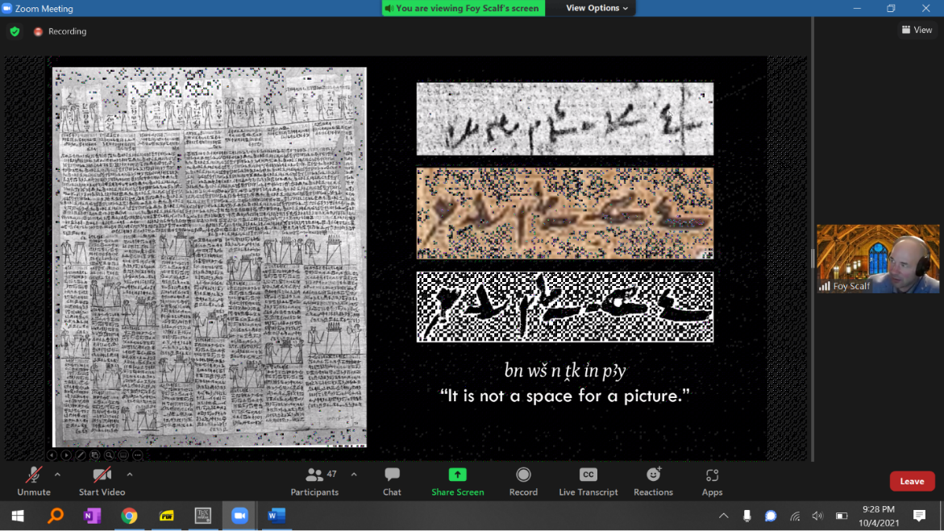

Hongqi: Could the illustrators work first? Foy: They can; we’ll get to examples of that. But in general the illustrator works last, not reading the text, just filling in empty boxes on the papyrus.

Examples where the scribe wrotenumbers in red, in Demotic, in the corner of each (or ideally each) illustration, for the sake of the illustrator’s guidance. Or, e.g., a small red note, “the hall of two truths.” These little memos are called *scribal cues*. We also see a similar phenomenon in medieval manuscripts, esp. when the manuscripts are “untrimmed.”

Dawn: Should they have erased these notes? Foy: I actually think no. You’d think that documents as important as these shouldn’t have this marginalia, but it’s not doing any harm. And in fact, as Rachel points out, it’s just offering more (good) textual redunancy.

The vast majority of the owners could not read their own BD papyri. Remember: At any given time, only about a few hundred(!) people in the country could read these ancient hieratic texts, mainly high-ranking priests. That said, some of the owners were the high-ranking priests.

“gm wS – what we might translate [to] Latin as, ‘lacuna’…”

Hongqi: Were the royals always literate in ancient Egypt? Foy: The assumption is yes, but we don’t know in every case for sure.

Rachel: 10% of ancient Egypt is still quite a lot of people though. Russian literacy in about 1900 is 20-25%.

“[The papyrus of Any is] one of the most celebrated BD papyri in the world…and yet you can see sheets patched together with uneven borders…”

The longest BD papyrus we have is Papyrus Greenfield, made for a singer named Nes-Ta-Nebet-Isheru. Over a hundred feet long. 90 separate panels[?] in the British Museum. We can see the scribes’ use of red glyphs to ensure that individual sheets were linked up correctly.

John Goldstein: Torah scrolls ca[n] be 124 feet long with 157 panels.

We see the same scribal cues used on other media for BD spells, e.g., linen bandages. You could literally wrap yourself in the Book of the Dead!

Also, we see the use of cues, tick marks, etc. for other texts – even stories like *The Eloquent Peasant*.

People sometimes disparage the Late Period and Ptolemaic BD papyri for being error-prone. But even an “exemplary” New Kingdom papyrus, like the papyrus of Any, has spells that just *break off* because there wasn’t room to finish writing the spell.

*10/10*

Papyrus of Nebseny (pL1), BD 125, Einleitung (Introduction)

<https://www.britishmuseum.org/collection/object/Y_EA9900-30>

*Transliteration*

1 Dd.wt xf.t spr r wxs.t tn nt MAa.ty pxA

sS-qd Nbsny nb imAx.t ir(w).n sS-qd *nw mAa.t hrw ms(w).n

2 Nb.t Pr Mw.t-Rs.ti mAa.t hrw

m xw.w nb ir.n=f mAA nTr nb Hr.w inD nTr aA Nb MAa.ty [?]

ii.n=i xr=k

3 Nb nTr=i

ini.t(w)=k wi mAA=i nfr.w=k

iw=i rx.k<wi> tw rx.kwi rn n nTr 42 wn.ny Hna=k m

4 wsx.t tn nt MAa.ty [?] anx.yw m …

*Translation*

1 What is said upon [Faulkner 190] arriving at this court [Faulkner 69, possibly derived from wsx, “wide”] of the Two Truths, [and] purging [Faulkner 93]

Scribe-craftsman Nebseny, lord of the blessed dead, made by [his father] scribe-craftsman Tjenu, true of voice, [and] born by [his mother]

2 Lady of the House, Mut-Resti [Gardiner T13], true of voice,

from any [kind of] wrongdoing [Faulkner 186] [“that he had done”], [and] seeing every god: Hail, great god, Lord of the place of the Two Truths,

for I have come before you,

3 Lord, my god,

that you may bring me to see [“that I see”] your excellence.

As for me, I know [stative] you, [and] I know the name[s] [Foy: the seated man is actually the determinative] of the 42 gods that abide with you in

4 this court of the place of Two Truths, who live upon …

*10/11*

*Sequencing Magic (BD Spells 1-16)*

*“‘Mighty Osiris,’ he said, ‘I present Ammut, who was called Samuel Whitford the banker in the upper world. I charge him with having attacked his conductors with the intent to do them bodily injury while they were guiding him, at his own behest, into the blessed realm of Karneter.’  
 The ibis-masked figure, holding a strip of papyrus before him, wrote rapidly thereon as if making a record of the name and charges.”*

*— Otis Adelbert Kline, “The Bride of Osiris”*

Spell 64: the spell to know all of the BD spells

Usually, the papyrus *recto* is the side where papyrus strips run horizontally, while *verso* is where they run vertically. This is intended to make writing smoother, when (hieratic) text runs in horizontal rows.

iw=f pw: “It is its end.”

Hongqi: Why are there so many cartouches? Foy: Actually, in this text, they aren’t cartouches. They are enclosures/mounds representing geographical locations in the Im-Duat. [Not always closed on all sides.]

Hypocephalus: Text written on a disk-shaped piece of papyrus and placed over the head of the deceased.

Dieter: At what age do individuals usually solicit a BD scroll? Foy: We don’t really know. We assume that people waited till adulthood, but that richer people ordered them earlier. We do have instances of children buried with BD scrolls, but we don’t know if they were pre-commissioned by their parents.

Clearly important that the papyri, or texts, were placed in close proximity to the body. Example where the First Book of Breathing was placed at the head, and the Second Book at the feet.

So, was the Egyptian religion fundamentally a *religion of book(s)*? Would surprise the medieval writers who argued that Christianity was the first religion in which gods were depicted with books in their hands! To carry a scroll is apotropaic: “It’s like a passport.”

Rozanne: Could a BD scroll be manufactured while the 70-day embalming process was going on? Foy: It’s possible that the manufacturing was carried out when death was near, or soon after death occurred.

Why does Foy argue against the “assimilate into Osiris, losing one’s identity” theory? Deep reason is that the Egyptians saw *differentiation*, i.e., separation from Nun,to be the fundamental principle of creation.

Why is the bA a bird? Because it’s solar: It can fly across the sky.

The netherworld was often conceptualized as being inside(!) the body of the sky goddess (Nut).

Saite Recension rubrics: grouped thematically, provide an outline of the afterlife theology.

Variation in rubrics. Funny example: “O Osiris, bull of the west, so said Thoth, lord of eternity” versus “O Osiris, bull of the west, so said Thoth, to lord of eternity” [which is correct??]. And in Any’s papyrus: “…so said Thoth, king of eternity, about me” (!).

Maryann: What does “justified” signify? Foy: In the Egyptian, the literal phrase is “true of voice,” which refers to being before the tribunal of Osiris in the hall of the 42 gods.

Answering Foy notes that our translations are sometimes influenced by Christian concepts. The use of “justified” probably doesn’t come from the connotation, “justified in Christ,” etc., but the translation of p.t as “heaven” rather than “sky” is certainly influenced by Christianity.

The last spell in these Saite Recension copies is usually BD 162, the hypocephalus spell.

Roman: How can Thoth make someone’s words true? It seems to me that they either committed those sins in life or didn’t. What am I missing? Foy: What Thoth says gets written down in the book, so to speak. Via magic, you get to influence what Thoth writes down and doesn’t. Roman: Pascal’s/Thoth’s wager :)

Foy: If you look at this BD 125 illustration, what do you see?

Hannah: Anubis is pulling the scale to make mAa.t heavier!

Foy: We see this detail in most BD examples. If you imagine yourelf as an ancient Egyptian, having done things you wish you hadn’t done, then you might want the gods to influence the scale in your favor.

Remember that mAa.t is the epitome of righteousness, so your heart can never be lighter than mAa.t, but at best, balanced with it. One possible intepretation of Anubis pulling the scale: The act of going before the gods and performing the negative confessions (for deeds that were, in general, a “higher order” of wrongdoing than most misdemeanors) was a purity ritual, intended to wash away the person’s “sins.” Fits with the purity rituals performed by priests before they could enter their temples: The texts are almost the same.

Creating an illustration of a positive result will, magically, help to make it true! “It’s kind of like a politician: If you say it enough times, it becomes reality.”

Spells identify the deceased (or, more accurately: the living owner prior to their death) with Osiris, with Thoth, etc. “I was with Horus on the day of clothing the dismembered god, opening the caverns, anointing the wearing of the heart, …” Note: These are oblique references to the myth of Osiris and Seth. They don’t rehash the entire myth, but only allude to it.

Sokar is the lord of Rosetjau. Image of the owner dragging the bark of Sokar across the river, from east to west.

Kathie: Wasn’t Horus born after Osiris became a mummy? Foy: There are actually several different versions of the myth. In one, Isis finds the phallus after Osiris is murdered but before his resurrection, and copulates with it alone; in another, the phallus is swallowed by a fish (“which then becomes an abomination”), and Isis has to create a magical replacement; the point is that there are variants.

The Egyptian gods are somewhat less determinate, less canonical, than we might expect. They are just personifications of an underlying magical force. They can reproduce sexually, asexually, or even through spontaneous generation. There is a myth where the god emerges from a lotus flower, and explicitly admonishes humans not to ask where he came from.

Mary: Hacking the earth???? Foy: “hacking” = “digging.”

Hongqi: “To Egyptians, life and death are all together. Were Egyptians messed up [*sic*] people?”

Foy, answering a question I asked: Yes, BD 162 (providing heat under the head of the deceased) is a solar thing.

*10/17*

Nebseny, BD 125, Einleitung, *cont.*

*Transliteration*

4 wsx.t tn nt MAa.ty [?]

anx.yw m sA.wt Dw.t

sAm.yw m snfw=sn

hrw

5 pwy n Hsb qd.wt m bAH Wn-Nfrw

mk %A.ty Mr.ty=f nt MAa.t rn=k

mk wi ii.kwi

6 xr=k

ini.n=i n=k mAa.t

dr{n}.n=i n=k isf.t r rmT.wt

n smAir=i wnDyw.t

n ir=i

7 iwy.t m s.t mAa.t

n rx=i nt.(y)t iw.t[?]

n ir=i

8 bw Dw

n ir=i tp-hrw-nb bAk.w m-Hr{w}

*Translation*

4 this court of the place of Two Truths,

who feed [“live”] off the guards [Faulkner 207] of evil,

who drink of [Faulkner 214] their blood [Faulkner 232],

[on] that day

5 of the weighing [“reckoning”, Faulkner 178] [of] characters in the presence of Wenneferu [Faulkner 62]:

Look, your name is [His] Two Daughters [hieratic sA bird, Roberson 11?], His Two Eyes [Foy: epithet for the uraei goddesses] of Truth.*

Look, I come

6 before you,

I have brought *maat* for you,

I have expelled [Faulkner 314-315] evil from humanity for you.

I have not impoverished [Faulkner 227] [my] associates [Faulkner 63].

I have not done

7 evil in the place of *maat*.

I have not known such evil [“that which is evil”].

I have not done

8 evil whatsoever [“altogether”, Faulkner 81-82].

I have not done daily [Faulkner 296] the labors [Faulkner 78] [?] …

*\** Foy: “You can see there is a complicated set of intertwined allusions between the mr.ty goddesses, the uraei, and the use of mr.t for ‘eye.’ Texts with the cobra determinatives suggest a reference to the mr.ty goddesses, who can still be alluded to with the eye determinatives.

“The text here is difficult since we also really want nb mAa.t[,] ‘lord of truth,’ instead of n.t mAa.t, which would suggest a feminine reference (n.t), which makes no sense with the masculine pronoun on rn=k. You can see how the scribe was wrestling with the passage (ju[s]t like us!).”

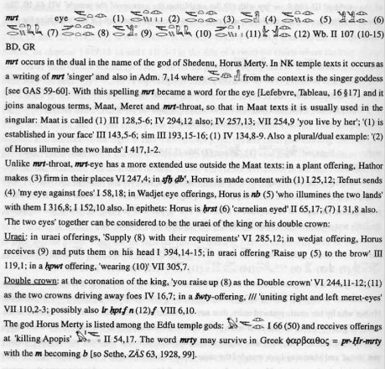

*10/18*

*Entextualizing Ritual (BD Spells 17-53)*

*“lf you’re right about the legend, then this casket may contain the Scroll of Thoth from the holy of holies in the temple. And l can hardly wait to get back to find out. The gods of Egypt still live in these hills, in their ruined temples. The ancient spells are weaker, but some of them are still potent, and l believe that you have in your hut the Scroll of Thoth itself, which contains the great spell by which lsis raised Osiris from the dead. Put it back. Bury it where you found it. You have read the curse. You dare defy it?”*

*—*The Mummy*(1932)*

Rozanne: Sun hymns [BD 15] often start the papyrus.

Two papyri that look very similar: Any’s and Hunefer’s. But Any’s is long and Hunefer’s is short.

BD 183 is a collection of hymns (“Hymns to Osiris, as a Follower of Thoth”), much like BD 15.

I got this wrong again: the Weighing of the Heart vignette can also accompany BD 30, not just BD 125.

BD 1 is recognizable from the vignette of the funeral procession.

BD 17 is recognizable from its length and its many vignettes: playing sn.t, the lions of yesterday and tomorrow, the bnw bird, the slaying of Apep, etc.

In papyri from the time of Iuefankh and Hunefer, we often see BD 1-15 grouped together.

“These are ritual texts, meaning they were not written to detail theological matters. Rather, the texts have an expressly ritual, functional purpose (to make things happen), into which theological material has been incorporated.”

“When an Egyptian says, ‘I am Thoth,’ it doesn’t mean they expect to sprout an ibis beak!”

Foy: “Thoth” is probably more authentic of a name than the reconstruction “Djehuty.” It’s just the name for Thoth used in the Hellenistic Period.

*Review of Spells 1-16*

BD 1 is an address to “Osiris, bull of the west, king of eternity.” Presented as the speech of Thoth, whose role the deceased assumes within the ritual. (“I am Thoth, who vindicates Osiris against his enemies on that day of judgment in the great temple of the magistrate which is in Heliopolis. I am the Busirite…”) Recounts Thoth’s role in the Osiris myth. (“I was with the mourners and lamenters of Osiris on the banks of the washerman… I was with Horus on the day of clothing the dismembered god, opening the caverns, anointing the weary of heart, passing the door of secrets of Rosetjau…”) Next turns to the other gods in the Hall of Osiris, commanding them to accept the deceased. (“…[M]ay you cause that the bA of Osiris Iuefankh, justified…draw toward the house of Osiris so that he may see like you see, so that he may hear like you hear…”)

Oral recitation by the deceased / by priests would have involved wearing ritual masks:

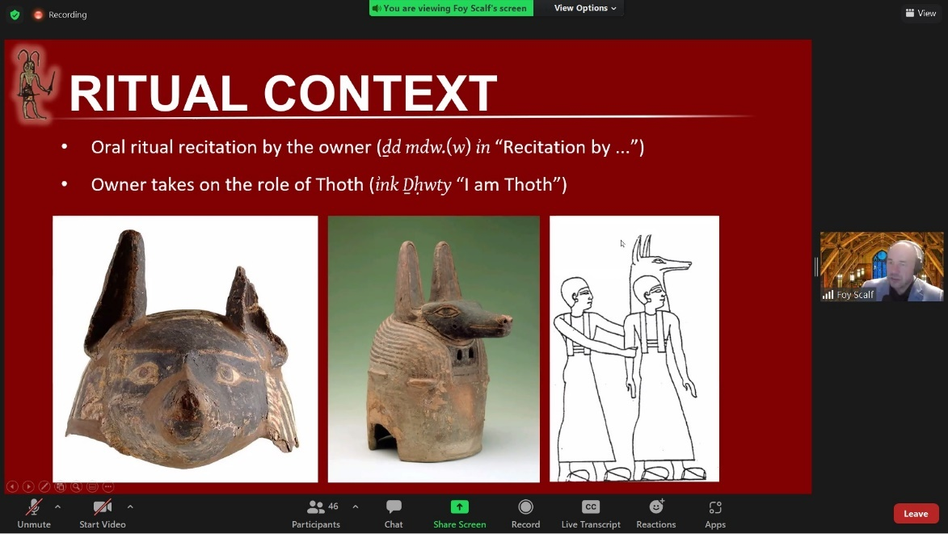

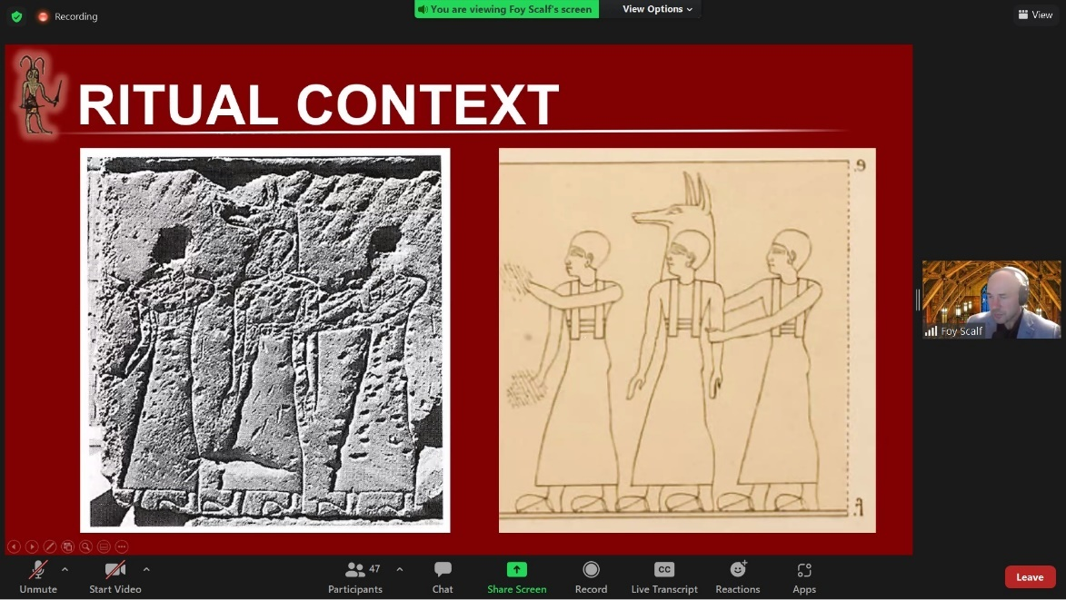

Thoth, in addition to being the god of writing, wisdom, and the moon, also served as a record-keeper and messenger for the other gods. His roles in the Osiris myth are as Osiris’s vindicator, the physician who helps restore Osiris to life, and the healer of the wounded left eye of Horus, as well as the one who revives the Horus-child in the marshes. Animal avatars include the ibis and baboon.

Why the ibis? An interesting connection: The Egyptians had several versions of an “alphabet,” or more precisely, a mnemonic ordering of the uniliteral signs. We have an ostracon(?) containing fragments of two of these, one on each side. The obverse one begins h-l-H-m-q and the reverse one begins e(?)-b-g-d-z. The obverse one is known as the *halaḥam*. On the ostracon, the associated mnemonic reads:

hAwhn rwy Harpw.t mwA r qA

* *hahāna lawi ḥalpat mayin le qab*

“to make pleasant, the one who bends [the] reed water [according] to the Qab”

However, there is another mnemonic for the *halaḥam* that reads:

…] pA !b Hr pA !byn pA Rd Hr pA Rr. […

…] r pA Wy Hr pA WrT r pA %mn Hr pA %ry

…] the ibis on the ebony [tree], the Rd-bird on the Rr-plant, […

…] the Wy-bird on the rose, the Nile goose on the %ry-tree

Rachel: The Egyptian word for “rose” looks cognate to the word in Arabic.

The full *halaḥam* is:

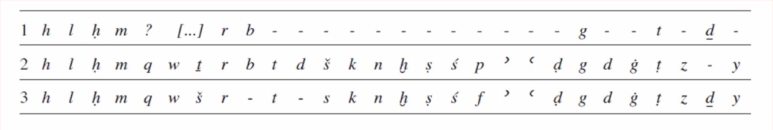

Note the recurring phrase in BD 1 and 43: ink Wsir pw nb nHH (“I am Osiris, the lord of eternity”).

Wsir pn (apposition or direct genitive) or Wsir n pn (indirect genitive)? Mark Smith argues for the latter in all cases. Some scholars have been overcorrecting in their transcriptions as a result. Regardlss: Foy and Smith both reject the hypothesis of a “mystical union” proposed by Morenz and Kákosy, while accepting the “liturgical union” hypothesis of Assmann. Returns to Foy’s theme that individuation represents creation, and more specifically, separation from the waters of Nun.

BD 2 is a “spell for going out in the day and living after dying”

The ritual of the Lamentations of Isis and Nephthys, performed during the Osirian Khoiak Festival, is related to the glorifications of the Ax spirits:

“Two women with pure limbs who have not given birth are brought. The hair of their body is removed, their heads adorned with wigs, tambourines in their hands. Write their names upon their shoulders as Isis and Nephthys. They will sing from the stanzas of this book before this god.”

BD 4 is “another spell of passing the upper way of the earth.”

BD 5 is a “spell for preventing that a man do work in the divine land.” Something weird about the bA “who came out in the hour, who lives on the innards of baboons.”

BD 6 is a “spell for causing that the answerer (wSbti) do work for a man in the divine space.” Crucial to note: The wSbti are avatars of the deceased person him/herself! We can deduce this from how the name of the deceased is inscribed on the figurines.

BD 6 is closely related to BD 110, which descibes how the deceased not only farms in the Field of Offering, but also receives offerings in their own right. Many popularizations of Egyptology miss this. Although parts of the afterlife do mimic the world of the living, other parts are totally different and magical and theological, e.g., riding in the solar bark with Re.

BD 7 is a “spell for passing by the sandback of Apep [while in the solar bark]. It is difficult.”

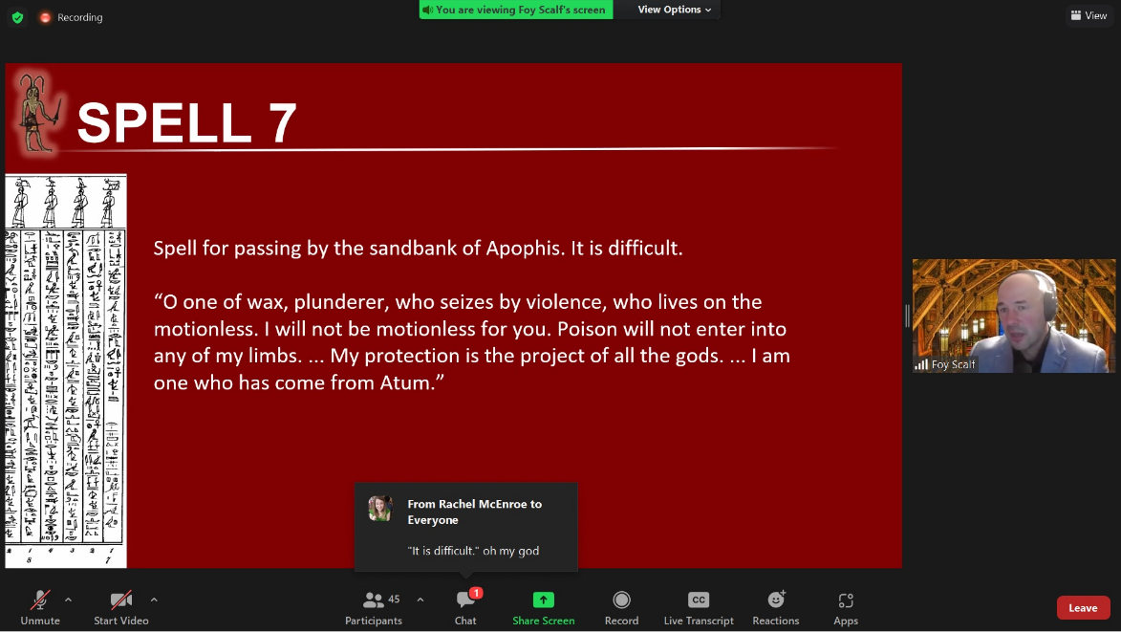

The Cat of Re, slaying Apep:

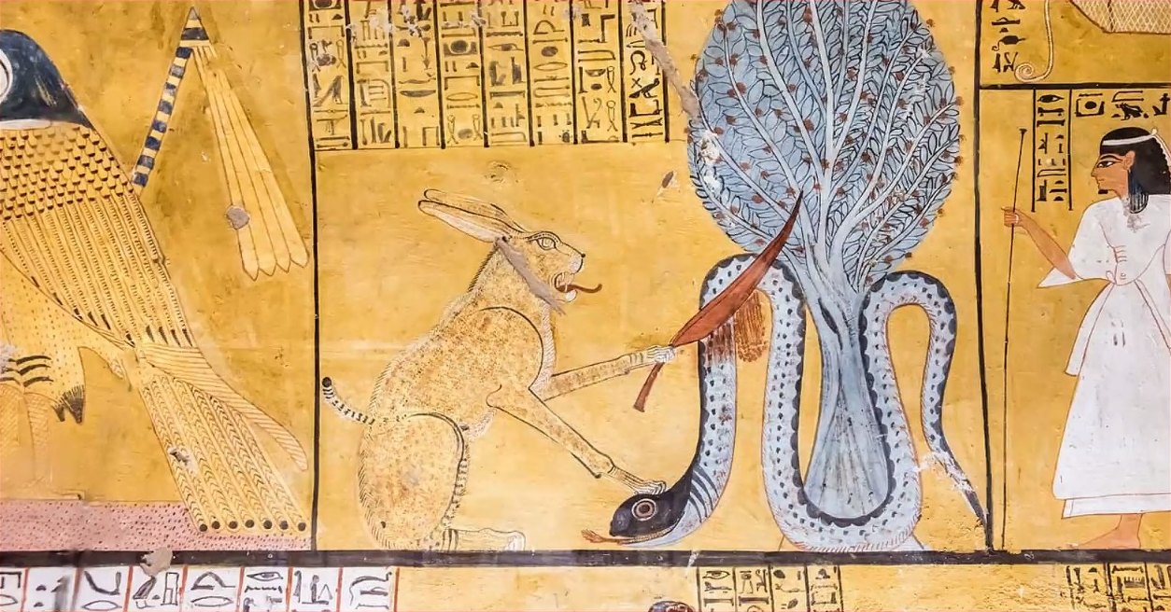

In BD 8, Seth takes on a positive role, defending the solar bark of Re from Apep. In BD 9, the very next spell, he returns to his negative role, as the opponent of Osiris.

The origin of Apep: When Neith gives birth to Re, she cuts off and discards his umbilical cord, which turns into Apep: a “snake of 120 cubits… His heart created the rebellion against Re with his confederates who came from his eye.” Apep, unlike Seth, is always described as evil! He is not dual to Re, but rather a discarded piece of Re himself. Compare to the dangerous snake formed from Re’s spit in “The Tale of Isis and the Name of Re” (Ritner 2017).

BD 8 through BD 14 are all concerned with “opening” and/or “going out” and/or “entering.”

Tripartie nature of Re: In the morning, he is Khepri; in the afternoon, Re; and in the evening, Atum. Explicitly stated in “The Tale of Isis and the Name of Re.”

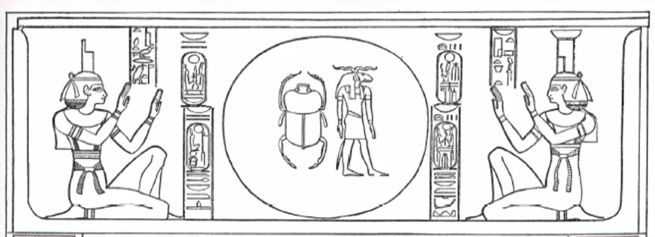

Khepri in the Papyrus Bremner-Rhind:

ink pw xpr=i m #pri

xpr.n=i xpr xpr.w

xpr xpr.w nb.(w) m-xt xpr=i

This means I came into being as Khepri.

When I came into being, forms came into being.

All beings came into being after I had come into being.

Compare the above to BD 15: “Hail to you, Re-Horakhty, Khepri, who has come into being himself.”

The Egyptians even mummified scarabs as part of Khepri-worship (gross!).

Atum means “the complete one,” referring to the evening sun at the end of its “life cycle.”

BD 16 contains imagery of solar worship by baboons. “The Egyptians’ keen observation of nature had led them to notice that at sunrise the baboons started to screech excitedly. They concluded that this must be a pious greeting of the god in a secret language.” Compare to a passage about knowing “the form of speech of the baboons and the ibses” in the Book of Thoth (“Conversations in the House of Life”).

Great Magical Payprus of Paris: “Enter, appear to me, lord because I call upon you as the three baboons call upon you, who speak your holy name in a symbolic fashion, A EE EEE IIII OOOOO YYYYYY OOOOOOO (speak as a baboon).”

Alexandra von Lieven: “Hymns mention that the king as well as private adorants become a part of the jubilating group of monkeys… That this monkey[-]screeching was indeed imitated by priests in the cult is proven by the ‘Book of the Temple’ where a teacher trains priests in a technique called ‘screeching,’ which ‘is indeed the same [word] as the one used for the noise made by the jubilating baboons and this is surely not by chance.’” (!!)

And another passage from BD 15: “The souls of Heliopolis will celebrate for him. The souls of Pe and Nekhen will elevate him. ‘Praise him!’ say the baboons.”

*Spell 17*

The papyrus of Iuefankh contains a typical Saite Recension rubric for BD 17.

Mary: Do you think the ptr rf sw was chanted in [call-and-response]? Foy: It probably was, but I don’t know for sure!

Foy: Nun is the “stuff” of creation all mixed together, without differentiation.

The primordial Ogdoad personify the characteristics of Nun:

Amun/Amunet = “Hiddenness”

Heh/Hehet = “Infinity”

Kek/Keket = “Darkness”

Nun/Nunet = “Inertness”

Interestingly, the names of the female gods are all written with egg hieroglyphs.

Hermopolis was #mnw, meaning “Eight Town.” The lord of Hermopolis was Thoth, hence the Greek name.

What does the creator god say of himself? Coffin Texts Spell 75: “I will tell you how I became my own form. Do not ask how I cam into being out of Nun. When I had come into being, Nun saw me. As I learned his name, so I learned the place from which I came into being. He did not see how I came into being with his sight.”

Coffin of Padiamun references the division into eight out of one: “I am one who became two. I am two who became four. I am four who became eight. I am one in his protection. I am Khepri in the temple of the pyramidion.” Elsewhere we find the epithet nTr wa ir sw m HH, meaning “the one god who made himself into million(s).”

Foy, answering a question of Rachel: nHH is cyclical eternity; D.t is linear eternity; HH, by comparison, literally means “a lot of numbers.” Rachel: “myriad”

*10/24*

Nebseny, BD 125, Einleitung, *cont.*

*Transliteration*

7 iwy.t m s.t mAa.t

n rx=i ntt [?]

n ir=i

8 bw Dw

n ir=i tp-hrw-nb bAk.w m-Hr{w}

9 ir.t n=i

n spr rn=i r wiA xrp

n sA-

10 -t=i[?] nTr[w]

n nm[H]=i n nm[H]

n ir=i bw.t

11 nTr[w]

n sDwy=i Hm n Hry-tp=f

n smr=

12 =i

n srm=i n smA=i

n wD=i n smA

*Translation*

7 evil in the place of *maat*.

I have not known [?].

I have not done

8 evil whatsoever [“altogether”, Faulkner 81-82].

I have not done daily [Faulkner 296] the labors [Faulkner 78] before

9 what I did [Hoch §157] [?].

My name has not arrived at the bark [Faulkner 56] of the administrator [196].

I have not weakened [Faulkner 209]

10 the god.

I have not orphaned [the second n is the beginning of the word nmH] the orphan [Faulkner 133].

I have not done the abomination

11 of the god[s].

I have not slighted the servant to his master.

I have not caused [Gardiner G37]

12 illness.

I have not caused tears or killed.

I have not given the command of killing [Faulkner 226] …

*10/25*

*Deification through Literature (BD Spells 54-106)*

*“Within were the papyri unrolled and beneath each of the documents, its translation, so far as they could be translated for they were somewhat broken. No. I, which was dated, In the first year of Peroa, appeared to be the official appointment of the Royal Lady Amada, to be prophetess to the temple of Isis and Horus the Child ... The second papyrus, or rather the translation, contained a most comprehensive curse upon any man who ventured to interfere with the personal sanctity of this same Royal Lady Amada ...”*

*— H. Rider Haggard, “The Ancient Allan”*

Payprus of Pasherashaikhet, Doorkeeper of Khonsu-in-Thebes Neferhotep: Dates from the Ptolemaic Period. Clues are (1) the orthography in the papyrus and (2) the owner’s name (rare in earlier periods).

Spells 17-53: Cosmology, theology, and praxis (e.g., apotropaic magic).

Spells 54-88: Spells for transfiguration (ir.t xpr.w) into other animals and gods to attain their powers and manifestations (bA.w).

Spells 89-105: Spells for joining the solar Osirian cycle and entering the boat of the sun god.

Spells 106-124: Spells for being among gods in the divine land.

Spells 125-136: Spells for becoming vindicated before Osiris, being transfigured (sAx.w), and joining with Re.

Spells 137-143: As one with Re, bringing light to the underworld and fulfilling the mysteries of Osiris.

Spells 144-154: Guide to the geography of the underworld, its association with the tomb, and the ability to leave the tomb.

The Egyptians saw themselves living in a world not of things, but of beings. Moreover, Egyptian mythology is heavily *imagistic* or *iconographic*: they used icons to encapsulate their beliefs, much like what one finds in, say, a Catholic cathedral.

Re-emphasized: the “multiplicity” of creation myths. Asexual reproduction, sexual reproduction, spontaneous generation, creation through speech / thought.

Explanation for the stars: Light coming out from holes in Nut’s body, as the sun passes through it. “[Her womb is] the eastern horizon. Her head is the western horizon. Her mouth is the west.”

The lions of the horizon = Lions of Shu and Tefnut. Sometimes personified as a single god named Ruti. Also sometimes shown with human heads and identified with a god named Aker.

“Yesterday is Osiris. Tomorrow is Re.” A reference to the duality between Osiris and Re. In more detail:

- sf, “yesterday,” is associated with the death of the sun.

- dwAw, “morning” or “tomorrow,” is associated with the rebirth of the sun.

- dwA.t, the underworld, is the place from which Re rises. In fact, a more literal translation of this word would be *tomorrow-land*.

Spell 18: An address to Thoth to ask for his vindication, just as Thoth vindicated Osiris at tribunals at various sites across the country during the struggle with Seth.

Spells 21-23: Associated with the opening-of-the-mouth rituals.

Rachel: The characteristic Egyptian obsessions are redundancy and “effectiveness.” Everything else is fairly universal-ish.

Spells 26-30: Spells for giving the owner his heart and preventing it from being taken from him.

Two words of heart in the Book of the Dead: ib versus HAty. Do they mean different things? We’re not entirely sure. The word ib is cognate to Semitic \**libb* and appears to be older. The word HAty is related to the preposition for “in front of” and appears to be newer. And there is a third word idr, cognate to Semitic \**dur*.

See Rune Nyord, *Breathing Flesh*, for some discussion of the conception of the heart in the Coffin Texts.

Warding spells against noxious creatures (BD 30’s) originate in older theological contexts, e.g., spells against snakes in Byblos, spells used by physicians in the “houses of life.”

Spell 42: repels the slaughter “which was done in Heracleopolis.” Associates each body part with a deity. “No limb of mine is free from divinity.”

Foy: Here’s a copy of the First Book of Breathing where BD 31-41 have been excised from the Saite Recension ordering; why? Perhaps an intentional omission, given that none of these apotropaic spells is as powerful as the statement of divinity in BD 42.

Spell 42 is also reminiscent of the Memphite Theology. The other gods are all body parts of Ptah.

Uraei figures: spit fire into the faces of the enemies of Re (or, in illustrations, into their decapitated necks).

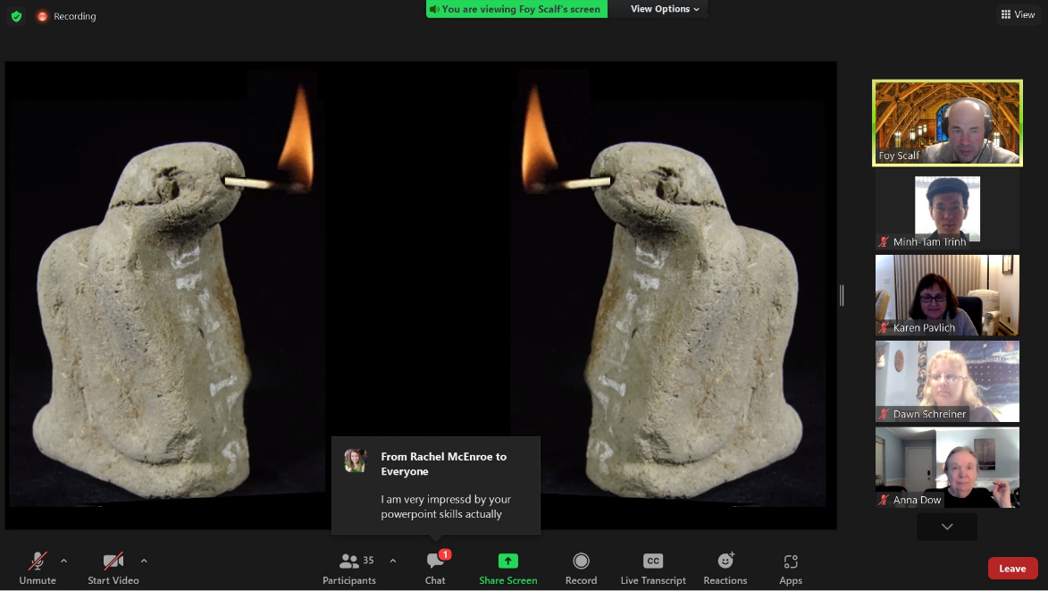

[The cigarette flames were animated]

Foy, responding to a question by Mary: The Egyptian word for “dreaming” literally means “being watchful/awake while asleep.” Rachel: In Russian, “dream and “sleep” are the same word.

*11/1*

*Mapping the Afterlife (BD Spells 107-165)*

*“… for it is written in the Book of Thoth how terrific is the price of a single glimpse. Nor may those who pass ever return, for in the vastnesses transcending our world are shapes of darkness that seize and bind.”*

*— H. P. Lovecraft & E. H. Price, “Through the Gates of the Silver Key”*

Foy: The Book of the Dead was likely used and viewed as an *amuletic instrument*, but not as a text to be read during the funerary rituals.

134 examples of divinization spells across the Book of the Dead, including:

- BD 32: “I am the beginning. I am Osiris.”

- BD 36: “I am Khnum.” / “I am Horus, lord of the circuit.”

- BD 54: “I am that egg that is with the Great Cackler.”

- BD 55: “I am Shu.”

- BD 69: “I am Anubis.”

- BD 95: “I am Re, who came forth from Nun. The god is my bA.”

Mary: Is Spell 80 for a flashlight?

Federn: Certain spells in the Coffin Texts and the Book of the Dead do not look as though they are specific to use by the deceased. E.g., specific references to actions taken by the living, before any burial.

Wente’s commentary on Federn: Perhaps the Egyptians were not looking for a mystical union with the universe in some “non-existential realm,” but rather, a state that would preserve, after death, the living existence that they thought depended on “diversification through the creative process.”

Sue: Was there communication between the bA’s of the dead and the living?—Did the dead play some sort of role in the everyday life of the living? Were they called upon to aid the living? Foy: Sue, you’re like 175 slides ahead of me.

Ritual recitation helps to “make [the spell] effective.” In particular, a poor person could still access the afterlife without a copy of the Book of the Dead, if a priest could ritually utter the spells on their behalf. But we don’t really know the extent to which these religious rituals appeared in the lives of the poor, since they left so few traces. On the other hand, there were many public festivals centered around the necropolis and its associated rituals: for example, the Beautiful Feast of the Valley.

Hongqi: [W]ould the dead all become gods after they came back to life? Or a dead king would become king again? And a poor man would still be a poor man after he came back to life? Foy: We think they believed that the social hierarchy would be roughly maintained, but even then, every deceased person would still be joining a *divine* entourage.

The bA bird returning to the corpse, as illustrated in Tutankhamun’s tomb:

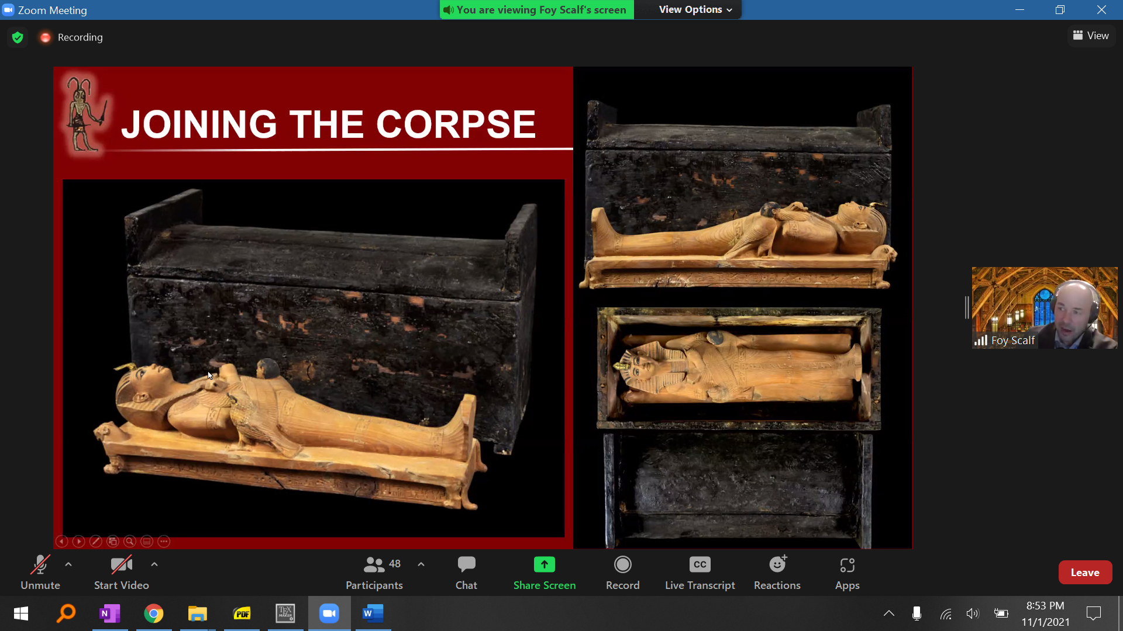

Spell 191: A spell for bringing the bA to the body.

Darnell:

- The Book of Nut asserts that the sun travels in the body of Nut both during the day and during the night, contiguously!

- The moment of “extreme cosmic danger” is at the midpoint of the night, called A.t, when the solar bark comes close to being grounded on the spine of Apep and the king, as a star, is in danger of falling out of the nether-sky into the place of “utter destruction.”

Foy’s “snow-globe” model:

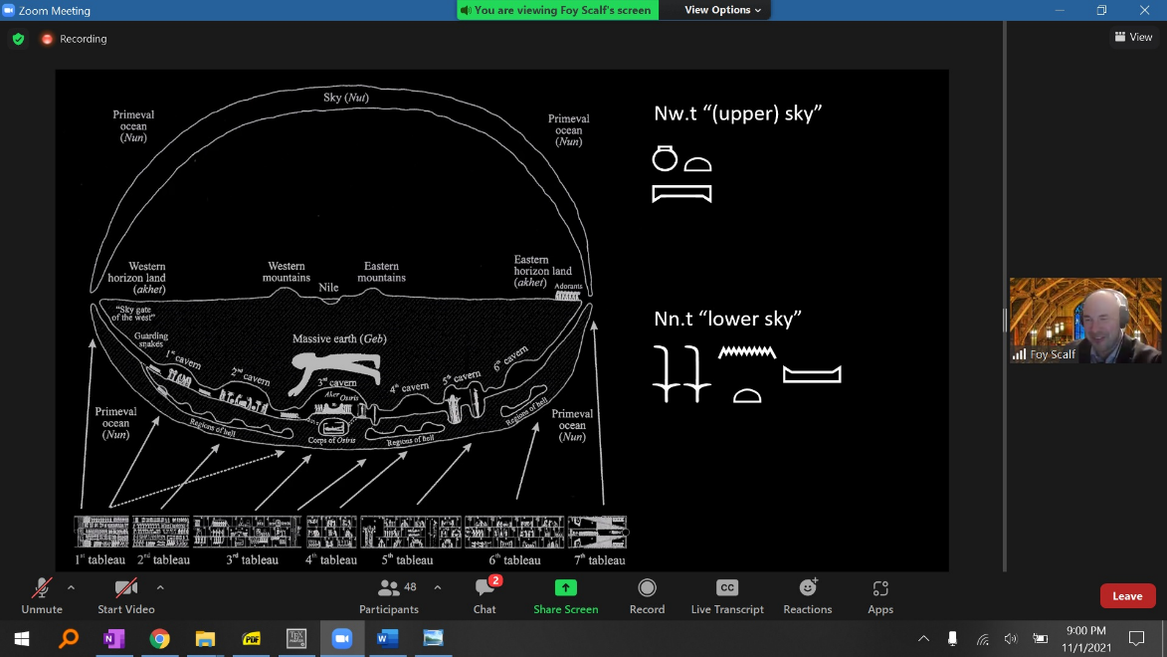

Foy: The Egyptians identified the northern sky (p.t mHt.t) with the “upper” sky (Nw.t) above the earth, and the southern sky (p.t rsy.t) with the “lower” sky (Nn.t) below the earth.

Excerpt from his Anubis article with Ritner: “Cause that he make the circuits of the foreleg-constellation (Ursa Major) across from the sow-constellation until you force him to make the journeys of the night sky(?) (cf. EG, p. 581; Wb. V, 132.9–11), until he seeks Taromeway, whom Tasib bore, there being no other woman at all.” As the article explains, this means the man will circle the constellation unendingly, unless he falls in love with the woman casting the spell.

The star Sirius disappears for 70 days: The length of time needed for the mummification ritual. Where does it go? Obviously, into the lower sky below the earth.

Richard: Is it like a gyroscope, and Nut turns over 180 [degrees]?

Connections to other cosmic magic: In a spell for hastening childbirth, we find a plea to Re and Aten, identifying the mother with Isis, claiming that if the birth does not happen, then “there will arise a weariness in the southern sky, [and] a disturbance will break out in the northern sky… Shu will not rise; Hapi will not flow when he should flow forth…” Dieter: Ancient Pitocin

Dissociation of physical versus social spheres:

- corpse (XA.t) versus mummy (saH)

- soul (bA) versus “social identity/memory” (kA)

- physical shadow (Sw.t)

- social name (rn)

The Ax is *all* of these things “reconstituted as you.” The Egyptian equivalent of our conception of “ghost.”

Foy: On the subject of social memory: <https://www.chicagotribune.com/suburbs/naperville-sun/opinion/ct-nvs-decent-column-st-0830-20200828-6jikjjgczjhmlft3nmy4c6ffqq-story.html>

The shadow, or rather, a shade to cast a shadow:

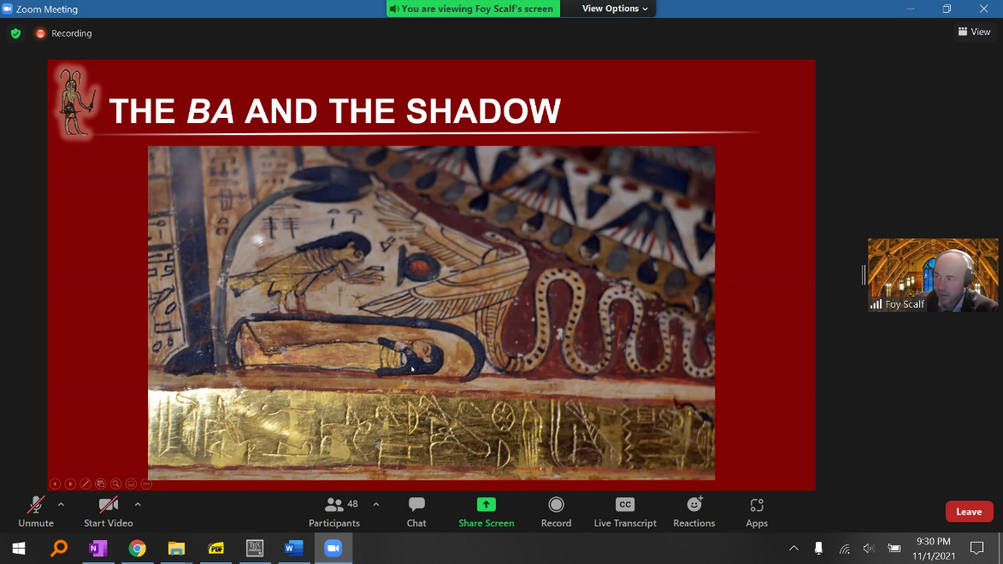

The shadow is referenced in the illustration for Spell 92.

Ammut devouring some shadows:

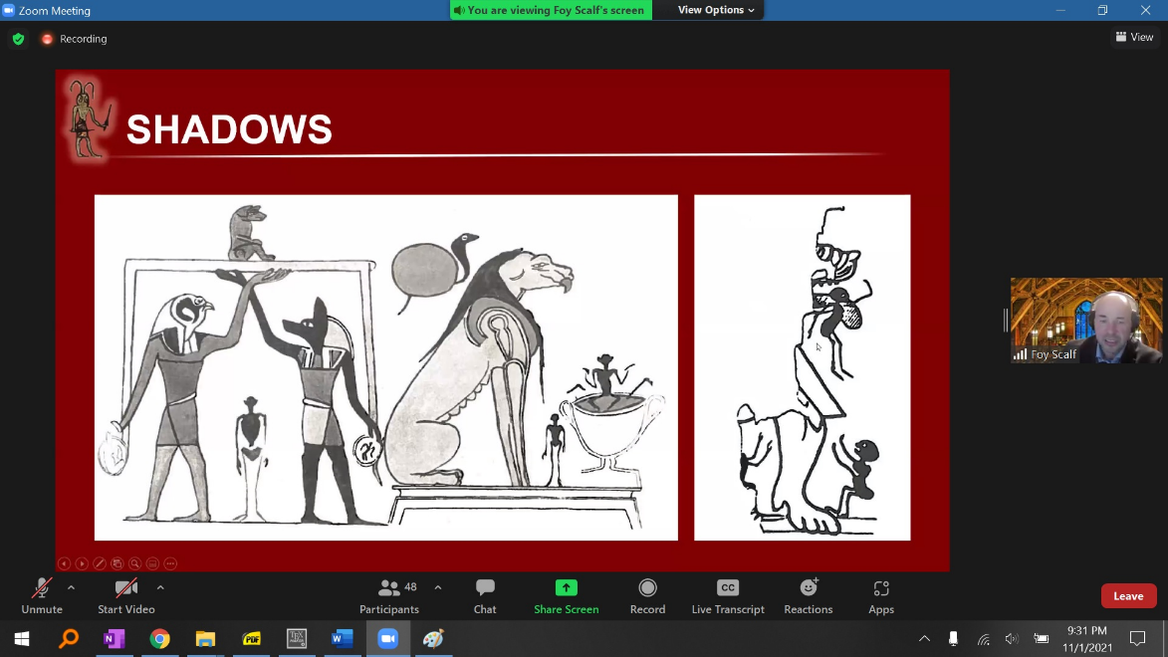

Spells 98-99: Spells for obtaining the ferry in the underworld.

Spell 110 describes both living activities transposed to the afterlife, and purely divine activities.

- “Beginning of the spells of the field of offering. A spell of going out in the day, entering and leaving from the divine land, joining with the field of reeds, … having power there, being transfigured there, plowing there, reaping there, eating there, drinking there, copulating there, doing everything that was done on earth there.”

- But also: “Being ‘Offering,’ lord of the field of offering: It is Horus who envelopes himself as a falcon one thousand cubits in length… He will go and he will come according to his heart’s desire from its lakes and from its cities. As he rises from the birthplace of the local god, so he rests in the cavern of the local god. He does everything in it just like what is done in the Isle of Fire.”

From a forthcoming article by Foy: “Looking for evidence of an elysian, heavenly paradise as [in] Western conceptions, commentators have largely disregarded the content of the spell by focusing on more convenient passages… The text itself descibes the duties of the individual to provide offerings to the gods by reaping and plowing in the field of offerings. As part of their imagined state in the field of offerings, a transmogrification takes place for the person…so that they too receive these offerings. Thus, the field of offerings is not simply a leisurely paradise, but requires the serious work of growing, reaping, and preparing the divine offerings. This is the very agricultural work performed by the wSbti statuettes—an individual’s avatar…”

Spell 125 includes imagery of birth bricks. The goddess of the birth brick: Meskhenet (Ms-#n.t). The birth brick was used as a type of stool for the mother during childbirth.

Also, the language of Spell 151 mimics the language in birth-aiding spells.

The language of Spell 125 itself resembles the language of priestly initiation oaths. The discoverer of the the list of oaths found in the papyrus known as the “Book of the Temple” initially believed he had found a copy of Spell 125.

*11/7*

Nebseny, BD 125, Einleitung, *cont.*

*Transliteration*

12 =i

n srm=i n smA=i

n wD=i n smA

13 m sma [?]

n ir=i mn.t Hr nb

n xbi=i Sb.w m

14 r.w-pr.w

n HD=i pA[?]w.t nTr.w

n nHm=i

15 xnf.w ax.w

n nk=i n dAdA.y

16 n wAH=i

n xbi=i m dbH

n xbi=i m Ssp [n i.t]

n siA.t=i m AH.wt

n wAH=i Hr mw.t n.t iw-

17 -sw

*Translation*

12 … illness.

I have not caused tears or killed.

I have not given the command of killing [Faulkner 226]

13 as [a] killer [why a instead of A?].

I have not created suffering [Faulkner 107] for any[one].

I have not taken from [Faulkner 187] the offerings of food [Faulkner 264] in

14 the temples.

I have not harmed the loaves [Faulkner 87] of the gods.

I have not carried off [Faulkner 136]

15 the cakes [Faulkner 192] of the effective ones.

I have not sodomized [“copulated”, Faulkner 142].

I have not masturbated [Faulkner 309, but see Quirke 271].

16 I have not set aside[?] [Gardiner V29 is wA],

nor have I taken from the requisition[s] [Faulkner 311].

I have not taken a palm’s width [Faulkner 271-272].

I have not encroached [Faulkner 212] upon the fields.

I have not added to [Faulkner 53] the weight [Faulkner 106] of the

17 balance [? determinative is Gardiner U38].

*11/8*

*Fragmentology and Papyrology*

*“By sheer will power, Tom Dawson stumbled towards the rear of the house and down through an auxiliary passageway to the lab. His object was to find the precious book of spells that was the key to the monster’s life on earth! ...*

*‘Good lord! These spells have to work! They must—or else nothing can stop this monster ... Nothing!’”*

*— “The Unburied Mummy”*

Wente: “…[I]t would also have been possible for the religious Egyptian to bring the future into this present, so that the realities of death and movement into

the netherworld with attendant rebirth could have been genuinely experienced in this life now without reference to the limitations imposed by the barriers of human time.”

Phrases from priestly oaths:

- Ending: ink wab iw=i wab.kwi (“I am pure. I am purified”).

- “I am Thoth, great one of the place of Re [ = Edfu]. I have come so in order to make my ceremony, baboons on my right side, baboons on my left side.”

- “I did not defile the god with my purification, for my hands are those of Horus and my arms are those of Thoth.”

Ritual purification of the king (in practice, the priest) with water before his entering sacred space: Probably happened four times, once for each cardinal direction. Gods flanking the king are often Horus(?) and Thoth, but can be others (Anubis, Sekhmet). Rachel: The water is made of anx’s!

“Negative confessions” are found even in the outer spaces, like courtyards, not just in the entrance to the main shrine.

The Book of Thoth:

- “It is actually a ritual for entering the chamber of darkness.”

- “I have made wine an abomination to me. I have forgotten the scent of myrrh.”

- Very similar rituals are described in the writings of Apuleius, specifically *The* *Golden Ass / Metamorphoses*.

Secrecy around the “mysteries”: As Apuleius’s protagonist says (in the Walsh translation), “Perhaps the reader’s interest in roused, and you are keen to enquire about the ensuing words and actions. I would tell you if it were permitted to reveal them; you would be told if you were allowed to hear. But both your ears and my tongue would incur equal guilt; my tongue for its impious garrulity, and your ears for their rash curiosity.”

Some BD spells that implore the user to keep them secret: 101, 115, 116, 133, 136, 137A, 144, 147, 148, 161, 162, 167.

Foy: The guardians at the gates in the underworld are not there to “freak us out,” but to ensure that only *the initiated* enter into the mysteries.

[Image of gate guardians from Foy’s slides]

Hongqi: How many gates are there in the BD? Foy: We don’t know exactly. A lot of manuscripts include 12, corresponding to the 12 hours of the night, but others don’t.

The “logo” Foy puts in the corner of his slides is a catfish-person! Not a bug-person!

Magical bricks: Inscribed with Spell 151 and placed in the walls to repel demons coming from each of the cardinal directions.

Spells placed at the head of the mummy: 151 (repelling demons), 42 (preventing the slaughter done in Heracleopolis and associating various parts of the body with gods), 43 (preventing decapitation).

Jar stands used in ancestor cults: Inscribed with a so-called letter to the dead. A jar/bowl of offerings would be placed atop the stand, in order to propitiate the ax spirit in question (that is, a deceased relative), helping them to intercede more *effectively* on behalf of the worshipper (e.g., curing their illness). Indeed, this is why the spirits are called ax = “effective.”

A literary instance of ax-spirit-as-ghost: See the Bentresh stela.

In Spell 162, we see the trigrams Lotus-Ram-Lion and Re-Khepri-Atum. Trigrams, written with three glyphs, represent esoteric / mystical names. Ritner interpreted Re-Khepri-Atum as a name of the one-god-who-becomes-many.

The opening of BD 1 is an address to Osiris. The end of the Saite Recension is typically BD 162, which usually opens with an address to the solar god (Re). Perhaps this is an intentional symmetry, enveloping the whole Book of the Dead within the framing of the Osirian half of the solar-Osirian cycle. Foy: “Placing a flame” under the head of the deceased seems to refer to being reborn with, and as, the rising sun.

Fragmentology/Papyrology:

- Baron Denon in Napoleon’s entourage: gave his name to a celebrated copy of the Book of Breathing of Isis(?) that he acquired

- Other famous names: Belzoni (better known for discovering the Younger Memnon), Athanasi, Salt, Rhind

- Moldenke (1860-1935): the “first Egyptologist of the New World” (though educated in Europe); his book *The New York Obelisk: Cleopatra’s Needle* is supposedly the earliest instance of hieroglyphic print done in America

- Sales catalogs from this time period (late 19th / early 20th century) that list papyrus items often give very suspicious descriptions (e.g., BD papyri are unlikely to have cartouches, or be rolled up with inscriptions on the outside of the scroll). Lots of fakes

- “The modern nation-state of Egypt has been very active in the past 10-20 years in cracking down on any illegal export of antiquities, and on getting large portions of [older] exports back… They tend to target the most famous [museums], because for the modern nation-state, this is about tourism… There are some things they really want back, and there are some things they don’t. But without getting too much into the politics of it, …the idea that the modern nation-state *owns* the antiquities from its [ancient] past is a *very* slippery slope. We wouldn’t want to say that about Native American antiquities owned by the *modern* nation-state of America.”

- Banana papyri! Foy showed an example where the forger transcribed what appears to be a real text (a BD scroll for an owner named Horemheb) onto the banana leaf

- An absolutely horrific example, now in the Getty, where the collector pasted together over a half-dozen random spells from the Book of the Dead into a single glob (some upside-down, most with lines totally cut off) (FMNH 31324)

*11/14*

Nebseny, BD 125, Einleitung, *cont.*

*Transliteration*

16 n wAH=i Hr mw.t n.t iw-

17 -sw n=s

n nmH=i m tx n n mhA.t

n nHm=i irt.t m r n nxn

18 n kfA=i aw.t Hr smw=sn

n sxt=i Apd.w n qs.w nTr.w

n hAm=i rm.-

19 -.w n [XA].w[t]=sn

n xsf=i mw n tr=f

n dni=i dni.t r mw Asw

n axm=i x.t

*20* m A.t=s

n [th]=i ss.w Hr stp.t

n Sna=i mnmn.wt Hr x.wt nTr

n xsf=i nTr m pr.w=f

iw=i

21 wAb.kwi sp 4

*Translation*

16 I have not added to [Faulkner 53] the weight [Faulkner 106] of the

17 balance [? determinative is Gardiner U38].

I have not tampered with the bob of the scale.

I have not seized milk from the mouth of a child.

18 I have not hidden the herds on their pastures.

I have not trapped [Gardiner T26] the birds of the reeds[?] of the gods.

I have not caught the fish

19 in their pools.

I have not blocked the water in its season [Gardiner M5].

I have not dammed the dam at the rapid water.

I have not put out the fire

20 in its moment.

I have not transgressed the days of [“upon”] offerings [of meat].

I have not turned back cattle from the properties of the gods.

I have not blocked the god in his passage.

I

21 am pure. (Repeat four times.)

*11/15*

*The Afterlife of the Book of the Dead*

*“I am Mentu his truth-telling brother,*

*Who was Master of Thebes from my birth:—*

*O heart of me! heart of my mother!*

*O heart that I had upon earth!*

*Stand not thou up against me as a witness!*

*Oppose me not, judge, in my quest!*

*Accuse me not now of unfitness*

*Before the great God, the dread Lord of the West!”*

*— Aleister Crowley, “A Ritual of Self Initiation Based upon the Formula of the Neophyte,” hand-written manuscript (Northwestern University)*

In Iuefankh’s papyrus, Spell 42 is written in blocks of text in columns with the owner’s name interposed horizontally between the blocks. The columns all use the same syntax, so this layout saves the scribe from having to re-write the name over and over.

Even in the New Kingdom, the Book of the Dead was definitely not the only funerary text in use. You can find instances where copies of the BD were placed together with copies of, e.g., the Books of Breathing, even though they drew from the same / very similar materials.

A huge source of finds: Bab el-Gasus in Deir el-Bahri, where many priests and priestesses of Amun were buried. Discovered in 1891, during the period of Khedive (i.e., Turkish) rule.

Most common method of forging papypri: Copying the text from a real papyrus.

An artifact about which Foy is still deeply unsure: The “HNMS” papyrus

The fragment attached upside-down in FNMH 31324:

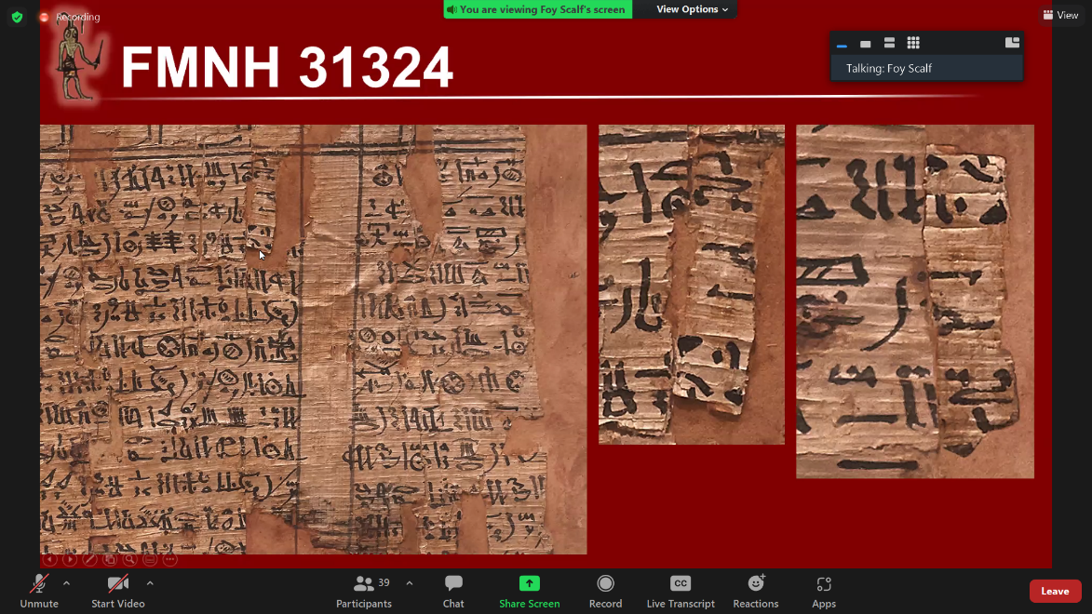

Chapin Library papyrus collection: How to tell the fragment on the first page is from the Book of the Dead? Look at the column fragment near the bottom showing the name of a god, a space, and then the top of the border of a mAa.t figure: Has to be from Spell 125.

Seven pieces from the papyrus of Userhat: Which is the beginning and which the end? The beginning is the very fragmented piece at bottom left. The end is the piece at top (far) right. Remember that New Kingdom BD papyri often end with Spell 150’s depiction of the mounds and the lake of fire.

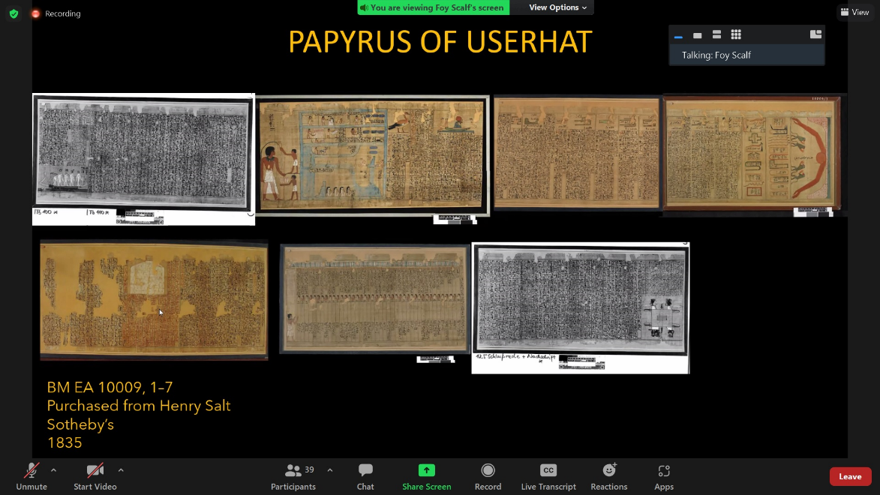

Foy was able to help a well-known medievalist, Christopher de Hamel, ID a papyrus fragment he had found. Turned out to be a fragment of the Book of the Dead belonging to a man named Petosiris. Other fragments of the exact same payprus are scattered everywhere: The British Museum, the Getty, the Hesburgh Library. In particular, the reason Foy recognized it was that he wrote an article about the Hesburgh fragment over a decade ago, but never got around to publishing it…

The Newberry Library used to have papyri fragments, but sold them in 1995 to a rare-books dealer in London named Sam Fogg. Foy reached out to Fogg’s to inquire which collector bought them. “We looked up the records, and the records were blank, so we don’t know who they went to.” “And I thought this was the biggest load of horse-you-know-what…”

Foy looked into Fogg’s catalogue’s description of a particular Book of the Dead fragment. The catalogue claimed it was Spell 125, but Foy noticed that the ending of a certain phrase did not match. It turned out to be “Spell 168”: not technically part of the Book of the Dead, but part of a text sometimes called “The Book of the Twelve Caves.”

A further punchline: The cover of the British Museum’s publication of the (Iuefankh??) Book of the Dead is an illustration from the Book of the Twelve Caves. So their cover is not even representative of the BD.

And a FURTHER punchline: The very day that Foy published his article about this payprus, someone reached out to him (over Twitter!) to tell him that (1) he had bought that exact papyrus (through an estate sale), (2) on the same day, and (3) found Foy’s article when he looked online for more information about what he had bought. The collector’s papyrus has now increased in value as a result of Foy’s publication. Mary: “Have him endow a lecture”

Egypt in America:

- 1823: The first Egyptian sarcophagus in America was brought to Boston by one van Lennep.

- 1826: Two mummies displayed at Peale’s Museum and the Gallery of Fine Arts in NY. Later in the possession of P. T. Barnum.

- 1832: Colonel Mendes Cohen returns from Egypt to Baltimore with 680 antiquities, formng the first private Egyptian-antiquities collection in the US. Donated to Johns Hopkins in 1884.

- 1835: Michael Chandler, an Englishman, tours the US with a collection including mummies, funerary items, and other papyri. Some were sold to the Mormon community of Kirkland, Ohio.

Mormonism and Egyptian papyri:

- Joseph Smith made a “translation” from one of the papyri that the Mormons purchased, which he then incorporated into his “Book of Abraham”: part of a larger Mormon religious text called *The Pearl of Great Price*.

- Smith’s illustrations seemed to be based on real sources, but also incorporate distinctly un-Egyptian features.

- Purely by chance, one Aziz Atiya discovered the actual source artifact for the Joseph Smith papyri in 1966. The un-Egyptian fabrications in Smith’s illustration correspond precisely to the lacunae in the source.

- Warren Parrish, scribe to Joseph Smith: “I have set by his side and penned down the translation of the Egyptian Hieroglyphicks as he claimed to receive it by direct inspiration of Heaven.”

- A sample Smith translation: “It was made after the form of a bedstead such as was had among the Chaldeans, and it stood before the Gods of Elkenah, Libnah, Mahmackrah, Korash, and also a god like unto that of Pharaoh, king of Egypt. That you may have an understanding of these gods, I have given you the fashion of them in the figures at the beginning, which manner of figures is called by the Chaldeans Rahleenos, which signifies hieroglyphics.” —*Book of Abraham,* 1:13-14

- The Egyptological translation of the same text: “[Osiris shall be towed in]to the great lake of Khonsu, and likewise [the Osiris Hor, justified,] born of Taikhibit, justified, after his two arms have been placed over his chest, while the Book of Breathing, being what is written on its interior and exterior, shall be wrapped in royal linen and placed under his left arm near his heart. The remainder of his wrapping shall be made over it. As for the one for whom this book this made, he thus breathes like the bA-spirits of the gods, forever and ever.”

- The Joseph Smith papyrus turns out to be a copy of a Book of Breathing that Isis Made.

- Robert Ritner received death threats over his work on these paypri. On the other hand, Ritner was also “extremely proud” to have received hundreds of letters of support from *ex-Mormons* for speaking out about them.

Another fine piece of Americana: Aleister Crowley incorporated real Egyptian religious texts into his occult religion Thelema. E.g., he asked a professional Egyptologist to translate a stela he acquired. Thus the “initiation ritual” in Thelema is actually drawn from Spell 30 (“O Heart of my mother!...”) of the Book of the Dead.

Mary: What are you working on now? Foy: “My two main projects [are] the Chapin Library fragments and the Getty Museum fragments.”

*11/21*

Nebseny, BD 125, Einleitung, *cont.*

*Transliteration*

*20* iw=i

21 wAb.kwi sp 4

ba.w=i ba

*Translation*

20 I

21 am pure. (Repeat four times.)